**System Requirements Specification**

Product Name: **QICPORTAL Component**

Change Name: **AWS-SQID-DATSI Migration**

Change Request Number:

|  |  |
| --- | --- |
| **Prepared By** | Mauro Zamora |
| **WA Project Manager** | Sonny Javed |

Revisions Posted to: [confluence location <Hyperlink only after final approval>]

Revision History

When revising the document, please include details in the ‘Notes’ column describing the specific changes made to initiate the revised version.

|  |  |  |  |
| --- | --- | --- | --- |
| Version | Date | Author | Notes |
| 0.01 | 09/01/2020 | Mauro Zamora | Initial draft |
| 0.02 | 09/18/2020 | Mauro Zamora | Updated Document: Diagram, Requirements |
| 0.03 | 09/23/2020 | Mauro Zamora | Added A13, QP 4.00  Updated QP 2.00, QP 3.00  Descope ESUBMISSION  Updated Document Types section  Link AWS - SQID - DATSI – Library spreadsheet to Attachment Section |
| 0.04 | 09/25/2020 | Mauro Zamora | Added link to DATSI Doc Notification Processing |
| 0.05 | 09/25/2020 | Mauro Zamora | Struck-out QP2.2 |
| 1.00 | 10/01/2020 | Mauro Zamora | Baseline Requirements |

Approvals

|  |  |  |
| --- | --- | --- |
| Approval Name and Position | Approval | |
| Date | Initials |
| Sonny Javed  Project Manager | 10/01/2020 | SJ |
| Ankur Jaswal  Director – Development | 09/30/2020 | AJ |
| Grady Herendeen  Manager – Business Process | 10/01/2020 | GH |
| Stephen Geng  Sr Analyst – Business Process | 09/29/2020 | SG |

Table of Contents

Revision History ii

Approvals ii

1. Introduction 1

2. Business Requirements 2

2.1 To-Be System Description 2

2.2 Assumptions 2

2.3 Operational Scenarios 3

2.4 Proposed User Interface/Mockups 3

2.5 Requirements 3

Appendix A: Glossary 5

# Introduction

**With the plan to migrate AWS during the first quarter of 2021, the following application will be utilizing DATSI repository.**

1. **QICTRK (Out-of-scope in this document)**
2. **QICPORTAL**
3. **eSUBMISSION (Out-of-scope in this document)**

**With SQID going away with the move to AWS, the following SQID process will need to be developed to bring documents from various sources to DATSI. (Out-of-scope in this document)**

1. **SCAN**
2. **FAX**
3. **AUTOUPLOAD**

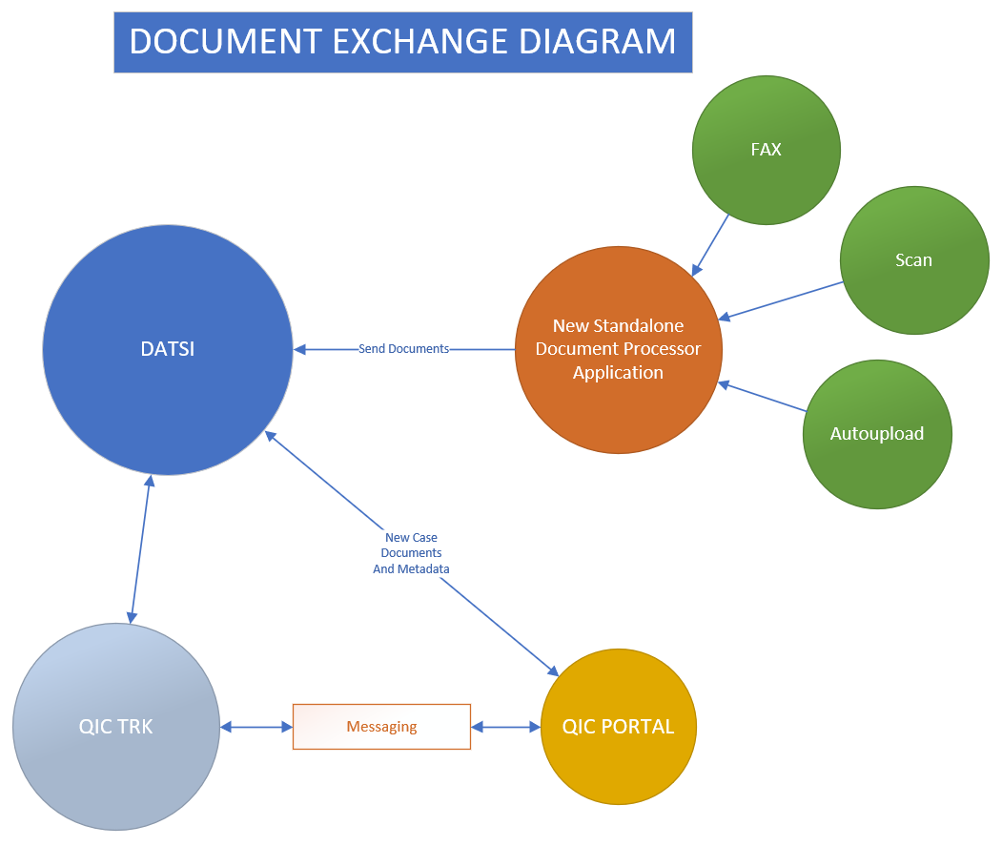

# Business Requirements

## To-Be System Description

|  |  |  |
| --- | --- | --- |
| **#** | **Description** | **Comments** |
| BR1.00 | 1. The following application shall be enhanced to directly integrate to DATSI and QICTRK systems.    1. QICPORTAL    2. eSubmission | [**FEDAP-3354**](https://jira.maximus.com/browse/FEDAP-3354)  [**FEDAP-3355**](https://jira.maximus.com/browse/FEDAP-3355) |
| BR2.00 | All documents that will be sent to DATSI shall have an associated project/part name. |  |
|  |  |  |
|  |  |  |
|  |  |  |
|  |  |  |

## Assumptions

|  |  |  |  |
| --- | --- | --- | --- |
| **#** | **Date** | **Description** | **CR#** |
| A1 | 09/01/2020 | QICTRK Changes will be discussed in a separate document/ticket. |  |
| A2 | 09/01/2020 | FAX/SCAN/AUTOUPLOAD will be discussed in a separate document/ticket. |  |
| A3 | 09/01/2020 | QICPORTAL and eSUBMISSION will communicate directly to DATSI |  |
| A4 | 09/01/2020 | DATSI will send notification to QICTRK when documents are received. |  |
| A5 | 09/01/2020 | All projects will be stored in a single instance of DATSI |  |
| A6 | 09/01/2020 | All projects will be In-scope: PART A, PART B (DME), PART C, PART D – LEP, PART D – DRUG. |  |
| A7 | 09/01/2020 | QICPORTAL/eSUBMISSION: The processes of creating a case, uploading of additional information will remain as-is. |  |
| A8 | 09/18/2020 | Document concatenation will not be changed. |  |
| A9 | 09/18/2020 | XML file will not be stored in DATSI. |  |
| A10 | 09/18/2020 | DCN will be provided by DATSI, and will be used by QICPORTAL to update the XML before sending to messaging layer for QICTRK consumption. |  |
| A11 | 09/23/2020 | ESUBMISSION will be discussed in a separate document. |  |
| A12 | 09/23/2020 | QICPORTAL is already sending notification to the business when error is encountered during document concatenation. |  |
| A13 | 09/23/2020 | Current set of document types will remain unchanged. |  |

## Operational Scenarios

### QICPORTAL (Backend)

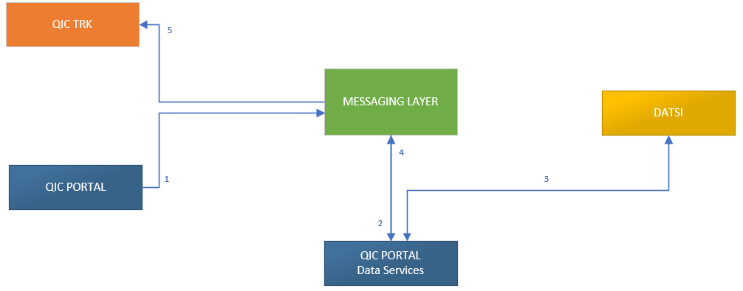

### eSUBMISSION (Backend)

Out of scope

## Proposed User Interface/Mockups

## Requirements

#### Requirements

|  |  |  |
| --- | --- | --- |
| SR # | System Requirements | CR/BR# |
| GENERAL REQUIREMENTS | | |
| GR1.00 | **DATSI Attributes:**   1. The attributes found in the spreadsheet (DATSI Attributes tab) found in Section 2.5.1.3.2 shall be setup and configured in DATSI.   Note:   1. In DATSI the field caption of the primary document attributes can be customized via the online portal setup / or database script according to business needs. 2. In DATSI, the other attributes can be added and configured via the online portal setup / or database script. |  |
| GR2.00 | **DATSI Requirement:**   1. DATSI shall not send notification to QICTRK when case documents have been received from QICPORTAL. (QICPORTAL will provide the txnServiceName).   *Note: DATSI will add the txnServiceName in the exception list so that notification will not be sent to the downstream system*.   1. DATSI shall send notification to QICTRK when case additional information has been received from QICPORTAL. (QICPORTAL will provide a different txnServiceName).   Note: Dev team will discuss with DATSi team. |  |
| GR3.00 | 1. Document types description and value shall be configured in DATSI either via the online portal setup or through database script. 2. The document types description shall align to QICTRK 3. The document types value shall align to SQID |  |
|  | **Refer to Section 2.5.1.3.3 regarding DATSI Notification Processing. The document discusses the processes and error handling in the event of failure to connect to the downstream system. (DATSI to QICTRK)** |  |
| QICPORTAL | | |
| QP1.00 | **Backend Processes Changes:**   1. QICPORTAL shall send the following documents to DATSI.    1. Case Documents    2. Additional Information 2. QICPORTAL shall provide the documents’ metadata to DATSI.    1. New Case documents    2. Additional Information (Temporary ID starts with A)   Note:   1. Additional Information QIC Appeal Number or QIC Temporary Appeal number is captured in the PDF file. The temporary ID number that will be provided to DATSI is the one starting in AYY-###### (i.e.: A20-001185). 2. Refer to the spreadsheet (DATSI Attributes tab) found in Section 2.5.1.3.2 for fields that need to be provided to DATSI. 3. QICPORTAL will use the SQID Priority values 4. Document Status = **NEW** 5. QICPORTAL shall receive DCN from DATSI and updates the new case metadata. 6. QICPORTAL shall send the new case metadata to the messaging layer to be consumed by QICTRK.   **Note**: Refer to Section 2.5.1.3.1 attachment for detailed technical and software documentation. |  |
| QP2.00 | 1. **QICPORTAL** shall provide a mechanism to allow admin users the ability to generate the case metadata for troubleshooting purpose. 2. ~~The solution shall provide the ability to re-send the case.~~ |  |
| QP3.00 | **Error Handling**   1. **Error Sending Documents to DATSI** 🡪 QICPORTAL shall send notification to the line of business when uploading new case documents or additional information.    1. The process shall stop here, QICPORTAL shall not send the XML to messaging layer. (Does not apply to Additional Information upload)   QP receives http response: 400, 401, 403, 411   1. **Error Sending Metadata to Messaging Layer** 🡪 QICPORTAL shall send notification to the line of business regarding the issue. 2. **Error consuming the new case metadata from messaging layer** 🡪 QICTRK shall send notification to the line of business regarding the issue. (QICTRK Requirement) 3. All notification shall be sent to the QIC PORTAL support mailbox: [qicportalhelp@maximus.com](mailto:qicportalhelp@maximus.com)    1. FEDAP Team shall be copied in the notification. [federalappdevelopment@maximus.com](mailto:federalappdevelopment@maximus.com)   **Note:**  **LOB will provide the email template which will be used by the system when sending notification.**   1. **Email Subject** 2. **Email Body**    1. **Include the temporary appeal number**    2. **Include the document names** |  |
| QP4.00 | Share with MD flag shall be removed from the metadata. 🡪 *QICTRK Dev team confirmed that removing of the Shared with MD in the metadata will not have an impact to QICTRK.* |  |
| ESUBMISSION | | |
|  | **PART A and PART C only. (Need to discuss with DEV team and what will change from today’s processes)**  **OUT OF SCOPE in this document**  **Assumption:**  **Backend processes most likely similar to QICPORTAL approach.** |  |
|  |  |  |
|  |  |  |
|  |  |  |
| DOCUMENT TYPES | | |
| Refer to Section 2.5.1.3.2 – QICPORTAL DOC TYPES Tab in the Spreadsheet.    DT1.00  The document types that will be setup in DATSI shall use SQID Values, description shall be aligned to QICTRK. Since QICTRK is already mapped to SQID Value, applying them to DATSI will reduce effort especially for historical data. The business decides to keep the setup as-is to minimize the impact. | | |

#### Future Considerations

N/A

#### Attachments

|  |  |  |  |
| --- | --- | --- | --- |
| # | Document Name and Description | Date | Attachment |
| 1 | QICPORTAL – SOFTWARE Design Specification | 09/09/2020 | [Link](https://confluence.maximus.com/download/attachments/190972245/DATSI-Integration-Design.docx?api=v2) |
| 2 | QICPORTAL - DOCUMENT TYPES | 09/23/2020 | [Link](https://confluence.maximus.com/download/attachments/208313255/AWS%20-%20SQID%20-%20DATSI%20-%20Library.xlsx?api=v2) |
| 3 | DATSI DOC Notification processing | 09/25/2020 | [Link](https://confluence.maximus.com/download/attachments/208313255/DATSI%20Doc%20Notification%20Processing%20-%20v2.pdf?api=v2) |

Appendix A: Glossary

**\*\*\* End of the SRS \*\*\***